[THE ROOTED LIFE

Colossians 2:7
‘…….continue to live your lives in him, rooted and built up in him…..’ from the Bible

Date: April/May 2024

A WBC MAGAZINE

Welcome to news from the Baptist family of Wymondham, Roots Community Café and the local community.

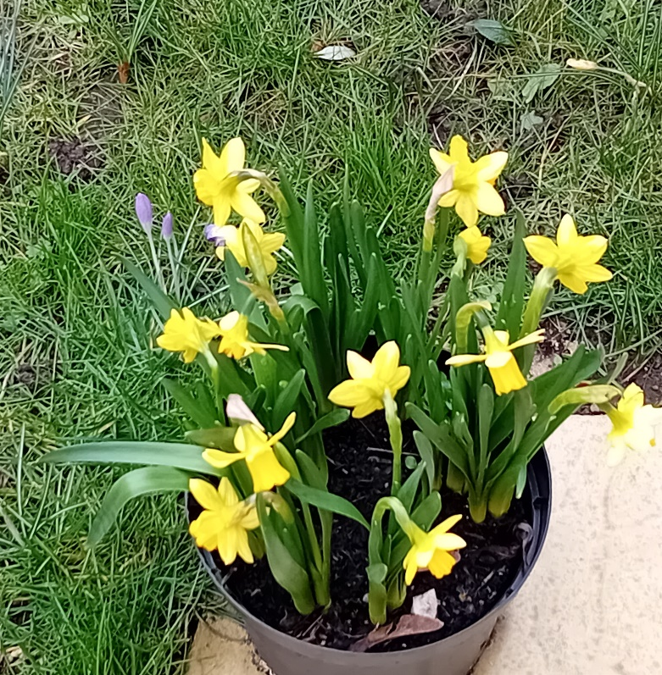

In this edition…

Find out what is happening at Wymondham Baptist Church in the coming months.

This magazine is brought to you by Wymondham Baptist Church. If you would like to know more about us, please call, e-mail us or visit our website.
Address: Queen Street, Wymondham NR18 0AY
Telephone: 01953 606520
E-mail: office@wymondhambaptist.org
Website: www.wymondhambaptist.org
Charity No: 1199302

Welcome to the sixteenth edition of our bi-monthly magazine.

We hope that you found the earlier editions interesting, this issue has more items of interest contributed by a variety of different people - we hope there will be something of interest to everyone. If you would like to write something for our next magazine, please drop it in to Wymondham Baptist Church Office by Sunday, 2nd June 2024.

In this edition we hope you enjoy the following…

Contents
- Message from our Pastor page 3
- A drama we won’t forget page 4
- A Word from Rosedales page 5
- Easter gardens page 6
- Do you know the answers? page 7
- Dates for April page 8
- Dates for May page 9
- Book the date page 10
- A Rocha ECO tips for May page 10
- Proposed Extension page 11
- World Day of Prayer page 13
- ECO Silver Award Celebrations page 16
- School Uniform Swap page 17
- A Rocha ECO tips for June page 17
- Craft and Crumpets page 18
- Something to think about page 18
- A poem …………. Page 20

A message from Paul Smith, our Pastor at WBC…..
As a busy person, trying to find time to slow down can be hard, but not impossible. As I shared in the last edition of this magazine I was suffering from writer’s block, which turned out to be a real blessing! I then focused on just ‘being’ and recognised how blessed I am. After all we are called human beings not human doings! Something I need reminding of often.
Talking of writing a while ago I read a book by an author called John Mark Comer, called the ‘Ruthless elimination of hurry’. In it he challenges the reader about being over busy but not productive. It is an extremely good, and challenging read, with lots of practical applications to implement. Some of which I have taken upon and sadly many which are, let’s say, a work in progress.

Recently I was gifted a second book of his from a friend called ‘Practicing the way’. It is all about discipling and following Jesus, becoming like him and doing what He did. I am being really blessed by this book. I was sitting in a rare moment of sunshine in our garden the other afternoon reading this book when the writer uttered the following words about spending time with God.

He says “Sometimes I sit there, Me looking at God, God looking at me and we just sit and I feel fully loved’.

Wow ….do you spend time with a loved one and just sit and look at each other? This May will be my 25th wedding anniversary. I am very blessed to be with Emma, a loving wife and my closest friend. On reflection our favourite moments during our marriage are not all the big ones, children’s births, holidays etc. though these are precious. Some of our fondest memories are the ordinary moments of day to day life. Of days just being in each other’s company. Both of us are driven people and like to be active, doing a task, or achieving something. Often I joke and say to people that “Rome wasn’t built in a day, only because Emma wasn’t there. She would want to know what was happening in the afternoon!”. If you have ever watched the Pixar film UP! This too is an example of a couple who enjoyed just being in each other’s company. It is seen in the reflection scenes of the film where Mr Fredricksen is remembering just sitting in his chair next to his wife simply holding her hand.
‘
Going back to the books both by the same author there is the reoccurring theme of slowing down and spending time simply being present. Perhaps it’s something you need to hear at the moment. Maybe you need to reflect and ask when was the last time you just sat with a loved one?
Have you ever sat and considered love at all? What it means and what are the ultimate examples of love? The Bible says that ‘ We love because He loved us first’ 1 John 4:19. It also says that God IS love. As I write this I am in preparation for Easter. A time for Christians across the world to reflect and remember the ultimate expression of love, “For God so loved the world, that he gave his only Son, that whoever believes in him should not perish but have eternal life”.
Have you ever considered how much God loves YOU?

Perhaps in the next few weeks you could sit with Him and just be looking at God, God looking at you and just sit and feel loved.

If you would like to explore more about what this all means then could I encourage you to come along to some of our services or maybe you could even consider joining us on our upcoming Alpha course which is an opportunity to explore the Christian faith and perhaps come to understand what it means to be fully loved.

I pray you enjoy have enjoyed this Easter and spending time with your loved ones even in the ordinary.

Blessings

Paul

A DRAMA WE WON’T FORGET

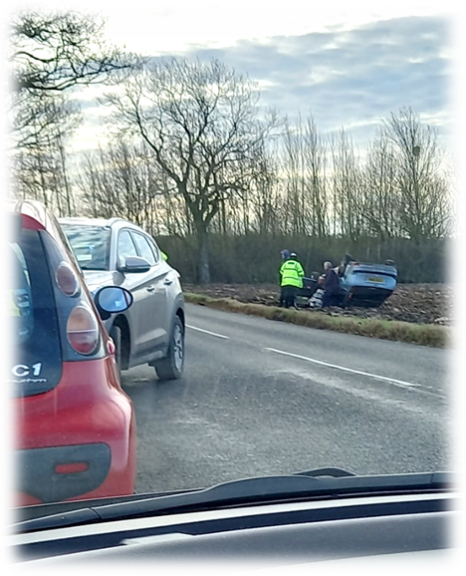
Nine of us clambered into three cars and in convoy made our way to hold our Home Group with David Fisher at The Mayfields Care Home, Long Stratton. We were driving along a country road when suddenly we saw a car coming round a sharp bend about 100 yards in front of us. It twisted, turned, flipped over and landed on its roof in a field. Of course, we stopped, and immediately Alan jumped out of his car and ran across to help the young lady who was upside down and held fast by her seat belt. Alan got it undone and, against all advice, the young lady crawled out of the car. Some of us gathered round her, covered her in a blanket and, of course, called the emergency services. Very soon three ambulances, four police cars and a fire engine all turned up, and statements were taken (one from Vic which, no doubt, was rather long!) After a while, as we were no longer needed, we left, but not before we saw the young lady walking safely to the ambulance.

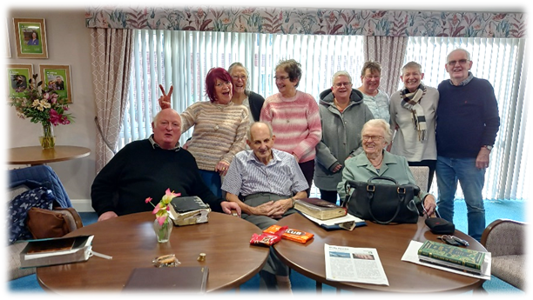
We continued on our way to see David who was so happy to see us, and we had a wonderful hour or so sharing the Gospel and praying with him. We didn’t know that this would be the last time we would see him – but what a happy time we had and what a blessing it was for him and for all of us and how privileged we were to have shared such a precious time.

Mary Wright

A word from Rosedale Bereavement Support……….
The physical symptoms of grief
The emotional effects of bereavement are well documented. Most people can identify with feeling of sadness, loneliness, disbelief, perhaps anger, guilt or regret. Sometimes relief can be felt because their loved one is finally at peace, especially if they had been suffering in pain due to a long illness.
Many bereaved people may also experience physical symptoms which were not present before, such as: Headaches, digestive upset or stomach ache, unexplained aches and pains and muscle tension. Not being able to sleep (or sleeping too much), feeling sick and not wanting to eat (or eating all the time) are also common physical symptoms of grief.
Feeling tired and exhausted is not unusual, as well as experiencing anxiety or panic attacks, which can cause shortness of breath, shaking, sweating and stomach pain.
As always, if we are worried about such symptoms, it is always best to speak to a doctor and get checked out.
However, grief can be exhausting. Our mind is taken up with mourning our loved one, every hour of every day, especially just after the death. We also still have to carry on with everyday life – going to work, looking after children or dependents, shopping, cooking, meeting with friends, family and neighbours. We may also have financial or health worries. It is no wonder our bodies and minds can feel stressed and overwhelmed.
There are many things we can do to calm the body and soothe the mind. Focussed breath exercises can help us to slow down and exist peacefully in the moment. Writing our thoughts and feelings down in a journal can also be a helpful way of ‘downloading’ anxious thoughts from our mind onto the page. It can help to see the blank page as a friend we are talking to, who is non-judgemental and has unlimited time to listen. It is there to listen at all times of the day or in the middle of the night.
Many people write letters to their loved one in their journal, saying all the things they may not have been able to say before they died.
Exercising, being outside in nature and engaging in creative pursuits such as drawing, painting, knitting, jigsaws, gardening, music, singing, writing etc can give our minds and bodies a brief rest from thinking about our loss, as we fully engage in an absorbing activity.
For those interested in channelling their emotions into poetry, Rosedale is sponsoring a poetry workshop, hosted by Lewis Buxton (poet, performer and author) on Saturday 8th June, 10 am-1pm at the Corn Hall in Diss. Tickets from the box office- 01379 652241

Easter Gardens

A huge 'thank you' to everyone who prepared an Easter garden for our display. They were all so different and each one focussed on a different aspect of the events of Easter weekend.
Thank you for all the time, thought and care that you put into your gardens...they were absolutely beautiful and really enhanced our Easter worship.

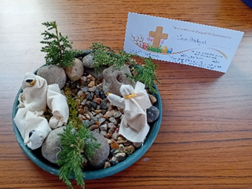
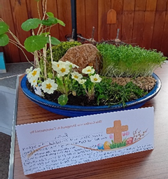
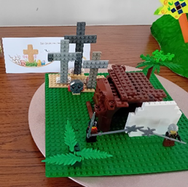
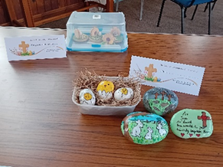
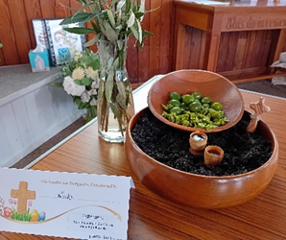
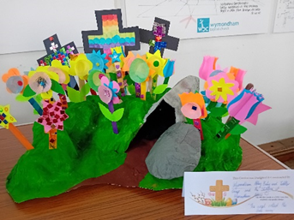
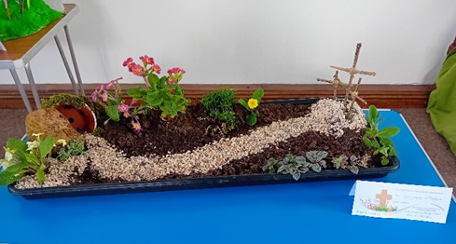

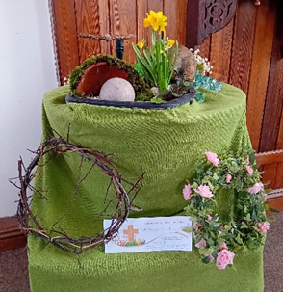
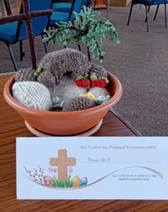
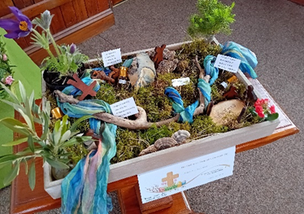

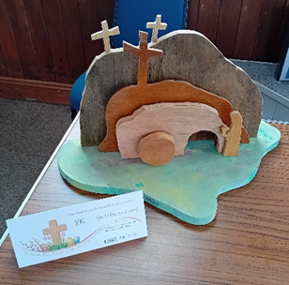

DO YOU KNOW THE ANSWERS?
- The dove brought back …………….. to Noah in the ark
Corn kernel, Grass spear, Olive leaf, Budding flower

- The Lord decided to destroy mankind in ……………
A flood, An earthquake, A fire, A hurricane

- The Israelites grumbled against God so that they spent ……… years in the wilderness
20, 30, 40, 50

- Moses came down from the mountain of …………. to deliver the 10 commandments.
Arab, Edom, Sinai, Ararat

- What did King Solomon ask for from God?
Money, Holy Spirit, A long life, Wisdom,

Dates for April
7th April Worship at 10.30a.m. – Guest Speaker – Rev. Bob Almond
9th April POWER HOUR in the Prayer Room – 10.00a.m.
10th April Roots Community Café @ WBC – 10.00a.m. – 1.00p.m.
11th April Home from Home – 1.30p.m. – 4.30p.m.
11th April Menscraft Group – 3.00p.m. – 5.00p.m.
12th April Roots Community Café @ WBC – 10.00a.m. – 1.00p.m.
12th April Uniform Swap at Roots
13th April Uniform Swap – 10.00a.m. – 12 noon
14th April Worship at 10.30a.m.
15th April ECO Team meeting at 3 Jackdaw Close – 10.00a.m.
15th April Leadership Team meeting – 7.30p.m.
16th April POWER HOUR in the Prayer Room – 10.00a.m.
16th April Thrive@Roots – 2.15p.m.
17th April Roots Community Café @ WBC – 10.00a.m. – 1.00p.m.
18th April Menscraft Group – 3.00p.m. – 5.00p.m.
18th April Alpha Course – 7.00p.m.
19th April Roots Community Café @ WBC – 10.00a.m. – 1.00p.m.
19th April Friday Night Youth – 6.30p.m.
20th April ECO Silver Award Celebration – 10.00a.m. – 12 noon
21st April Worship at 10.30.a.m.
23rd April POWER HOUR in the Prayer Room = 10.00a.m.
23rd April Elders meeting – 10.00a.m.
23rd April Thrive@Roots – 2.15p.m.
24th April Roots Community Café @ WBC – 10.00a.m. – 1.00p.m.
25th April Home from Home – 1.30p.m. – 4.30p.m.
25th April Menscraft – 3.00p.m. – 5.00p.m.
25th April Alpha Course – 7.00p.m.
26th April Roots Community Café @ WBC – 10.00a.m. – 1.00p.m.
27th April Craft And Crumpets – 1.00p.m. – 4.00p.m.
28th April Worship at 10.30a.m.
28th April Church AGM – 12.30p.m. (Election of Deacons)
28th April Praise and Worship at 7.00p.m.
30th April POWER HOUR in the Prayer Room – 10.00a.m.
30th April Thrive@Roots – 2.15p.m.

Dates for May
May 1st Roots Community Café @ WBC – 10.00a.m. – 1.00p.m.
May 1st Rosedale Monthly meeting – 10.00a.m.
May 2nd Menscraft Group – 3.00p..m. – 5.00p.m.
May 2nd Monthly Prayer Meeting –
May 3rd Roots Community Café @ WBC – 10.00a.m. – 1.00p.m.
May 3rd Friday Night Youth – 6.30p.m.
May 4th Alpha Course – 10.00a.m. – 3.00p.m.
May 5th Worship at 10.30a.m. including Communion – 10.30a.m.
May 7th POWER HOUR in the Prayer Room – 10.00a.m.
May 7th Thrive@Roots – 2.15p.m.
May 8th Roots Community Café @ WBC – 10.00a.m. – 1.00p.m.
May 9th Home from Home – 1.30p.m. - 4.30p.m.
May 9th Menscraft Group – 3.00p.m. – 5.00p.m.
May 10th Roots Community Café @ WBC – 10.00a.m. – 1.00p.m.
May 11th Appraisal Training for Leadership Team 10.00a.m – 12 noon
May 12th Worship at 10.30a.m.
May 13th Leadership Team meeting – 7.30p.m.
May 14th POWER HOUR in the Prayer Room – 10.30a.m.
May 14th Thrive@Roots – 2.15p.m.
May 15th Roots Community Café @ WBC – 10.00a.m. – 1.00p.m.
May 16th Menscraft Group – 3.00p.m. – 5.00p.m.
May 16th Alpha Course – 7.00p.m.
May 17th Roots Community Café @ WBC – 10.00a.m. – 1.00p.m.
May 17th Friday Night Youth – 6.30p.m.
May 19th Worship at 10.30a.m.
May 21st POWER HOUR in the Prayer Room – 10.30a.m.
May 21st Elders Meeting – 10.00a.m.
May 21st Thrive@Roots – 2.15p.m.
May 22nd Roots Community Café @ WBC – 10.00a.m. – 1.00p.m.
May 23rd Home from Home – 1.30p.m. – 4.30p.m.
May 23rd Menscraft Group – 3.00p.m. – 5.00p.m.
May 23rd Alpha Course – 7.00p.m.
May 24th Roots Community Café @ WBC – 10.00a.m. – 1.00p.m.
May 25th Leadership Team Away Day
May 26th Café Church at 10.30a.m. – The Lion King
May 26th Praise and Worship – 7.00p.m.
May 28th POWER HOUR in the Prayer Room – 10.00a.m.
May 29th Roots Community Café @ WBC – 10.00a.m. – 1.00p.m.
May 31st Roots Community Café @ WBC – 10.00a.m. – 1.00p.m.

BOOK THE DATE ………………

JUNE 15th – HAPPY DAY GOSPEL SINGERS GIVING A CONCERT AT WBC

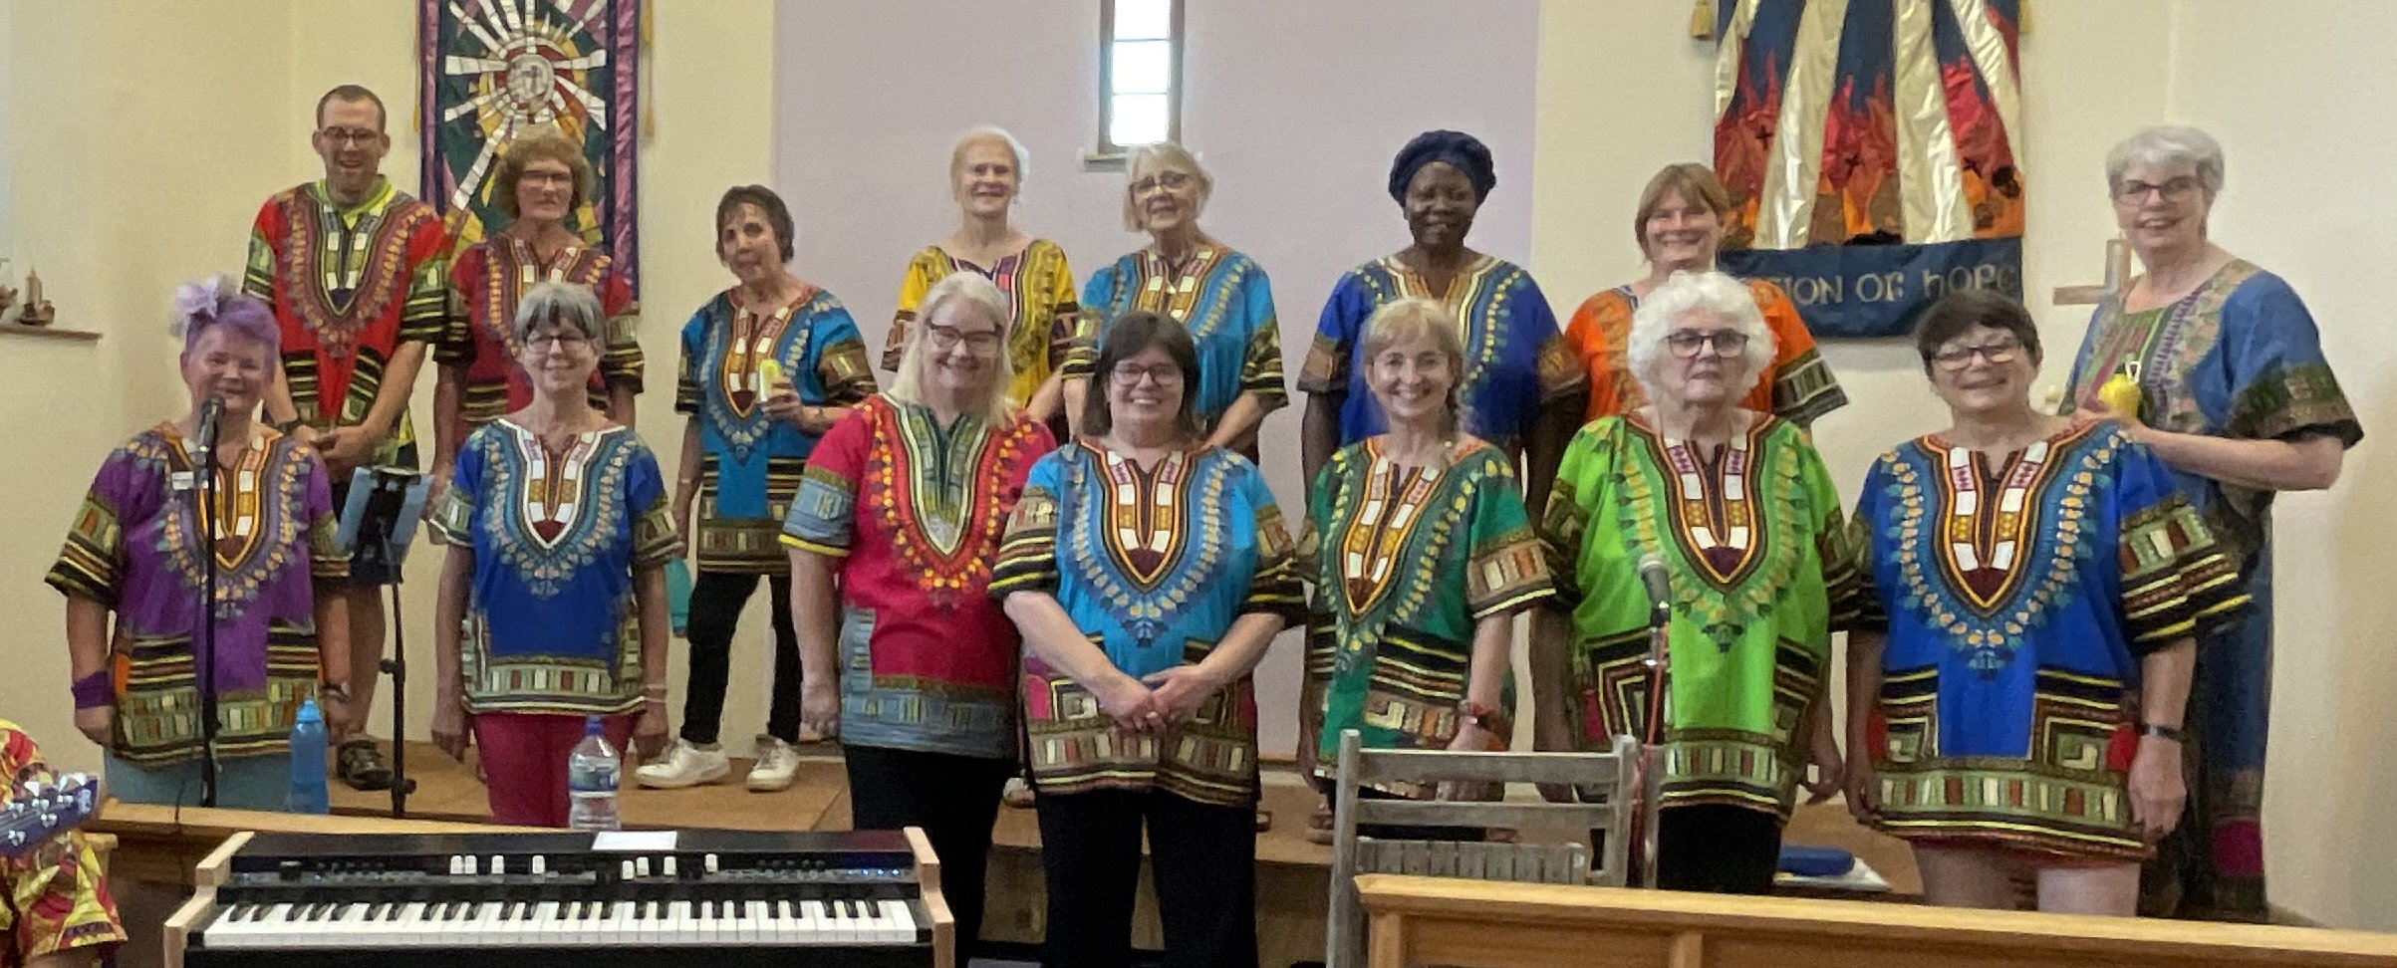

WATCH THIS SPACE – MORE INFORMATION TO FOLLOW

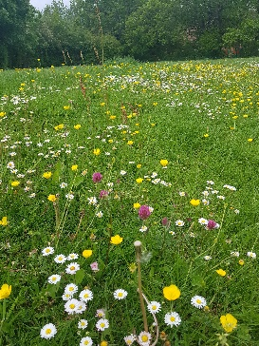
A ROCHA EASY ECO TIPS FOR MAY

Say No to the mow. Mowing your lawn less and letting parts grow long saves you time and helps give nature a home. If you want to make an even bigger impact on wildlife, wait to mow your lawn or a section of it until August to support even more animals.

Proposed Extension – Phase 2 is now starting in April 2024!
Summary

Phase 1 - Planning Permission

Received December 2022

Phase 2 - Detail Design Development

• Prepare detailed drawing
• Prepare specifications for the work
• Identify Building Control requirements
• Engage architect, structural engineer and independent energy consultant
• Obtain contractor pricing and refine cost estimate
Phase 3 - Construction

No commitment to construction will occur without specific approval of the Church Members. We do not have a firm date for when construction will start. The earliest start date would be in the Autumn of 2024, but Spring 2025 is more realistic, providing we have the funds. The budget for the overall project (all three phases) is approximately £500,000.

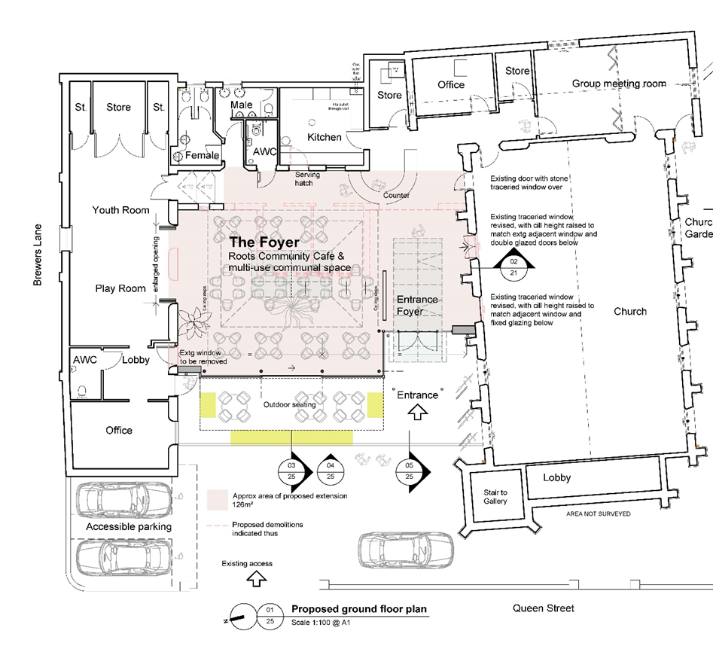

Progress on Phase 2

A summary of the expected costs for Phase 2 was received by the Church Members Meeting on 19th November 2023 and approval was given to carry out this work, subject to the necessary finance being in place. The costs are summarised below.

LWA architects | £18,000
Other professional fees | £5,538
Site investigations | £900
Energy consultant | £2,700
WBC contingency, 10% | £2,714
GRAND TOTAL | £29,852

Phase 2 takes the planning permission already received in Phase 1 and develops the detail design drawings, specifications and drawings needed to obtain real pricing from contractors. It includes much work from the architect, and input from a structural engineer to design the required steelwork and foundations. We will also take advice from an energy consultant on the proposed heat pump included in the design and finding out about the feasibility of using solar panels to reduce our electricity bills. The timescale to finish this work is not fixed, but it is likely to take three months or so to get to the point at which we could go out to contractors for pricing. We may pause at this point, to review where we are at with overall funding for the project, as we don’t want to go out to tenders twice. Please pray for David Frith and Paul Smith as they liaise with the architect John Western and others during the Phase 2 work.

How do we pay for this?

So far the church has managed to raise the funds necessary to achieve planning permission, and to upgrade the kitchen following a flood due to a broken pipe, and to balance the books for 2023. We give God thanks for this and particularly now that we have the funds necessary in the Building Fund to pay for the Phase 2 work. God has been good to us.

We also give thanks to God that the efforts of Grace Burke and a small team of dedicated helpers (the “External Fund-Raising Team” have been rewarded and that the application to South Norfolk Council for a community grant towards the cost of this Phase 2 work has been approved. This will cover a substantial part of the cost of the Phase 2 but we still have to pay the invoices first and reclaim the grant afterwards, with a lag between the two.

Thank you for your prayers and contributions. The fund-raising efforts will of course continue as we carry out this Phase 2 work. Please pray for Grace Burke and Kate Kinsey (and the rest of the “External Fund raising team” as they seek grants for Phase 3 – Construction. Please don’t feel embarrassed if you are unable to contribute directly – prayer for the project is even more important. If you have other imaginative ideas for raising funds do let us know. Details of how to give are below.

The existing buildings

In looking at interfaces with the existing buildings, we are also looking at smartening up the north elevation of the church …. which may look scruffy compared to the new extension. Cleaning of the north wall is included in the church’s maintenance budget and is planned for early April 2024 – indeed it may be done by the time you read this. The windows still need further consideration. We have monitored the peak usage of our existing electricity supply and the report is being reviewed. The aim is to ensure it will be adequate for the future. Also during 2024 we aim to think about how much we may or may not be able to use the premises while construction is taking place.

How to give?

There are various ways you can give.

1) On the premises. There is an opportunity for you to give your offering as part of our Sunday worship or whenever the church is open. Envelopes marked “Building Fund are available. A donation terminal is also available, which takes payment by credit or debit card. There is a button on the screen to indicate what are of WBC work you wish to support.
2) Giving through your bank - if you would like to make a donation by BACS, please ensure that it is marked 'BUILDING FUND'. Payments should be made to the credit of Wymondham Baptist Church account: Sort code: 30-90-89 Account No. 47748863
3) By leaving a cheque or cash at the Church Office or in the Offering Box in the church.
4) By visiting our Just Giving page for the Building Fund

5) By visiting the WBC website and following the links on the ‘Giving’ tab.

If you pay UK tax please consider Gift Aid - a form can be obtained from the office. This enables the church to increase the value of your donation by 25%.
If you need help or more details, please contact Cathy in the office on Tuesday, Wednesday r Friday morning or by e-mail at office@wymondhambaptist.org.

David Frith

World Day of Prayer 2024

On Friday 1st March, a good congregation gathered from churches across Wymondham to worship together and pray for Palestine and the surrounding area in their troubled times. Written by the Christian women of Palestine, the service focussed on the need ‘to bear with one another in love’ (Ephesians 4, verses 1-7).

It was a very moving service and it was a privilege and blessing to be part of a wave of prayer that swept across the globe over that 24 hour period. During the service, we sang the following hymn by Fred Khan:

Put peace into each other’s hands
and like a treasure hold it,
protect it like a candle flame,
with tenderness enfold it.

Put peace into each other’s hands
with loving expectation;
be gentle in your words and ways,
in touch with God’s creation.

Put peace into each other’s hands
like bread we break for sharing;
look people warmly in the eye:
our life is meant for caring.

Put Christ into each other’s hands,
he is love’s deepest measure;
in love make peace, give peace a chance,
and share it like a treasure.

We then listened to this powerful reflection:

‘Put peace into each other’s hands…
A prayerful reflection on the opening lines of Fred Kaan’s hymn
by Elaine Barnett
Put peace into each other’s hands
And like a treasure hold it
Put peace into each other’s hands.
Put peace – it requires action, Lord.
Prayerful action.
Not just hoping for something,
yearning for something,
even praying for something,
but actively doing something.
And, put peace into each other’s hand, Lord?
But what about my viewpoint and opinion?
Because to put something into someone
else’s hand means
giving it away,
not holding on to what is mine,
letting go.
It might be a bit easier
if I knew I would be giving it to those I know and love,
those I trust.
But what about the ‘other’?
those who are different to me?
those I don’t agree with?
those I’m not sure I can trust?
My thoughts, viewpoint, hopes, prayers – given away.
And as I stand, momentarily empty-handed,
how do I feel?
There is a vulnerability in giving, offering, peace.
Will it be rebuffed? mocked?
Or accepted? welcomed?
Put peace into each other’s hands
And like a treasure hold it
Like a treasure hold it.
A reminder, Lord, that this is something precious,
this gift of peace we give each other.
Having given, can I now recognise its worth?
Can I treasure it?
Indeed, can I even accept it?
That’s not so strange a question as it may seem.
Because, again, it’d be easier from those I know
and love,
those I trust.
But can I receive from the ‘other’?
those who are different to me?
those I don’t agree with?
those I’m not sure I can trust?
Surely one of the most significant parts of the Parable
of the Good Samaritan
lies in the wounded traveller accepting help,
care and provision,
from one of the Samaritans, who were so despised –
very definitely – the ‘other’,
the ‘different’
the ‘I don’t agree with them’
the ‘I never trusted them’.
Giving and receiving peace
requires generosity of spirit,
openness and trust,
as well as the humility to accept.
It’s a precious thing, then!
Lord, grant us grace to
Put peace into each other’s hands
And like a treasure hold it.
Amen’

Peace is fragile, peace is indeed precious and cannot be guaranteed. Let’s continue to ‘bear with one another in love’ and pray for peace in our fractured world.
Nicki
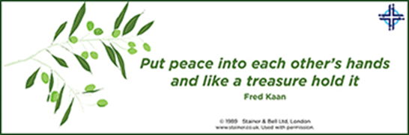
The words of the hymn and reflection were taken from the order of service for the World Day of Prayer service on the 1st March 2024 which was prepared by the Christian women of Palestine and printed here by kind permission of the World Day of Prayer charity.

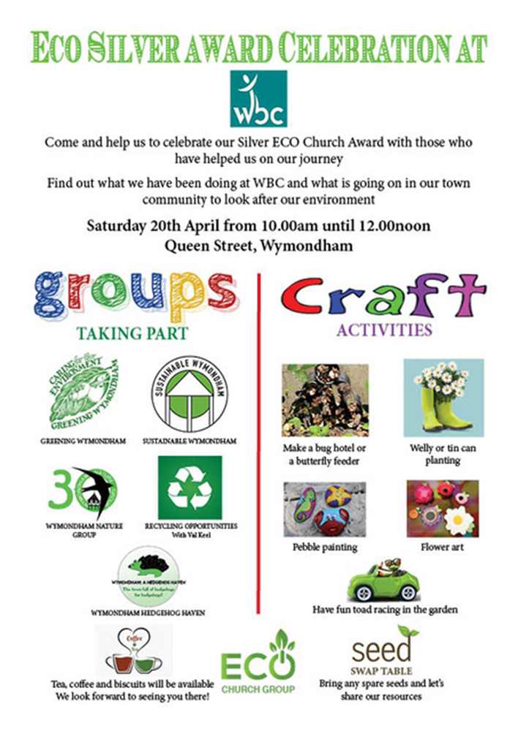

Please come along and support this event. We are also asking you to collect, wellie boots that your children have grown out of, lou roll middles, egg boxes, glass jars and tin cans. Please leave these in the Church Office. Thankyou.

Please make sure your friends and neighbours know about our Uniform Swap. We have lots of uniform to offer to anyone who needs it.

A ROCHA UK’S EASY ECO TIPS FOR JUNE

Join 30DaysWild. One of A Rocha UK’s firm beliefs is that we are mor likely to nurture and defend God’s creation if we spend time enjoying it. The Wildlife Trusts’ 30 Days Wild challenge is a great opportunity to engage with nature as an individual, household, or with your church community throughout June. Find some wild ideas at wildlifetrusts.org/30-days-wild

Please come along and share in this event. If you have a hobby you would like to display, please sign up, so we know to expect you. Items for sale in support of the Building Project, so come along and share in each others talents.

…………………………………..

Something to think about

The parable of the talents, Matthew 25: 14-30, tells how a man going on a journey entrusted property to his servants, giving one of them 5 talents, another 2 and another 1. When he returned the servants who had been given 5 and 2 talents had doubled the money in his absence. To them he said “Well done, good and faithful servant” But the man with only 1 talent said “Master, I knew that you were a harsh man,”...”so I was afraid, and I went and hid your talent in the ground. Here you have what is yours.” His master called him wicked and lazy, took his talent away and gave it to the one with ten talents, and then threw him out.
I worried that I would end up like that man. I felt so unproductive in my Christian life. I especially struggle with social anxiety, and I always felt certain that a good Christian ought to be able to be more sociable. But some days it’s more than I can cope with to just walk out of my house. When I was diagnosed with autism a couple of years ago that explained a lot of my difficulties, but it did nothing at first to alter my lifelong feelings and perceptions of being “other” and “less than”. (Sadly those tend to go together in our society.)

Socialising is draining for me, I don’t have an instinctive understanding of it. Over the years I have got by through trial and error, trying to interpret the other person’s body language in my mind during the conversation. I have read library books about body language, but it’s more difficult in real life, because movements flow very quickly. You don’t get a snapshot which you can identify at leisure. In a crowd with overlapping conversations I can’t help overhearing parts of them all, and I have to concentrate hard on the one I am involved in. I imagine and mentally rehearse social situations beforehand and analyse them in depth afterwards, and I have nurtured a supply of “small talk” for general use. But I get tired and stressed quickly, it’s like the mental fog you get after sitting a difficult exam. Because of all this, I am often reluctant to socialise in the first place, and I thought that I was a disappointment to God and to the church, and I should really be doing much better, even after my diagnosis.
But at last I have spotted something else in those verses. It says there that the servants were given talents “each according to his ability.” When the master returned, he didn’t say to the one with 2 talents “Your colleague here made 5 talents, why didn’t you?” Both were blessed. I wonder whether the man with only one talent felt that he hadn’t much to offer, so why bother. (Would anyone really miss his contribution?) He also had a critical attitude towards his master, he describes him as a “harsh man”. It is often harsh trying to live up to unrealistic standards, our own or other peoples’. We could sometimes even end up blaming God for our burdens, although He never asked us to do more than we were equipped to do. And avoiding the responsibility altogether, by burying it in this case, certainly doesn’t look like the answer.(!)

I have often misused the verse “I can do all things through Christ who strengthens me” (Philippians 4 : 13) in the past, thinking that it covered any personal goal. God can and does call people to do extraordinary things for Him, but then He also gives them the strength and guidance to accomplish it, not just in their own strength or through the fear of man. God completely knows me and what I am capable of, and that includes my autism. I may be a one talent Christian when it comes to social skills and charisma, but He has a plan for my life, and by His grace I will be where I am meant to be, doing the things I am meant to do, however small.

Tracey Westlake

A poem……….

I’m sure many of you already know this poem or have heard it before. I hadn’t, so when I read part of it recently, I thought I would share it here. What does it say to you?

(It was written by vicar and WW1 army chaplain Geoffrey Studdert Kennedy who, after the war, became a pacifist and a Christian socialist, working for the Industrial Christian Fellowship. He became an outspoken advocate for the working classes.)

Indifference
or
When Jesus came to Birmingham

by

Geoffrey Studdert-Kennedy
(1883-1929)
Matthew 25:31-46
When Jesus came to Golgotha
They hanged Him on a tree,
They drave great nails through hands and feet,
And made a Calvary.
They crowned Him with a crown of thorns;
Red were His wounds and deep,
For those were crude and cruel days,
And human flesh was cheap.

When Jesus came to Birmingham,
They simply passed Him by;
They never hurt a hair of Him,
They only let Him die.
For men had grown more tender,
And they would not give Him pain;
They only just passed down the street,
And left Him in the rain.

Still Jesus cried, “Forgive them,
For they know not what they do.”
And still it rained the winter rain
That drenched Him through and through.
The crowds went home and left the streets
Without a soul to see;
And Jesus crouched against a wall
And cried for Calvary.

