THE ROOTED LIFE
Colossians 2:7
‘…….continue to live your lives in him, rooted and built up in him…..’ from the Bible

Date: August/September 2022

A WBC MAGAZINE

Welcome to news from the Baptist family of Wymondham, Roots Community Café and the local community.

In this edition…

Summer reading ……………………………………..

Welcome to the sixth edition of our new bi-monthly magazine.

We hope that you found the earlier editions interesting, this issue has more items of interest contributed by a variety of different people - we hope there will be something of interest to everyone. If you would like to write something for our next magazine, please drop it in to Wymondham Baptist Church Office.

In this edition we hope you enjoy the following…

Contents
- Message from our Pastor page 3
- Do you recognize this?? page 4
- Summer Activities page 4
- Who likes a good puzzle page 4
- A Word from Rosedales page 5
- Cryptic Song Titles Quiz Answers page 6
- A picture to colour page 7
- A challenge for the summer page 7
- August/September dates to remember page 8
- Freezer Savvy page 9
- Love every drop? page 10
- Beware page 10
- Caution page 11
- Don’t waste food – some ideas page 11
- A good book page 12
- Energy Saving Tips page 12
- Bike, Walk, Drive page 13
- Big Church Clean/Clear Out page 13
- Children Eat for Less page 13
- Home from Home page 14
- Save the date and save your tools page 15
- Some photos from our gallery page 16

A message from Paul Smith, our Pastor at WBC…..

Hi another addition of our magazine is upon us. I cannot be the only one who sometimes sits there and think how fast is this year going! As I wrote these words I looked at our last edition and see that I had written those words last time too…. Rather than edit and re-write I thought perhaps God is trying to tell me something.
You see this is our summer edition and I have a strange feeling about summer. It is not my favourite time of year. Now don’t hear me wrong I am not a miserable old man, well not always, but summer is always a funny time. It is always highly anticipated with promise. We look forward to hopes of glorious sunshine and holidays to other destinations like we are looking for some kind of escape. However, the weather is never quite what we hoped it would be, as typical English it is either too hot, not sunny enough, raining or never as glorious as it was when we were growing up.

And then there are the school holidays…..

Children want your attention, can we go here dad? is asked. Work needs signing off before we can go away…so much to complete and then the toughest, of how much am I coming back to after the break creeps in…..and all the while I think can I have five minutes peace!
But then it happens….I sit down in the garden and look up in the sky. Behold there are some beautiful swallows swooping in the clear blue sky. Diving, soaring, majestic. It is idyllic, stunning and peaceful. A reminder that we can find peace in the ordinary day. It also reminds me of the fantastic world God has blessed us with. One of so much beauty that we don’t need to escape to see, or wait and go to a far flung place necessarily, but one that is right here and now. One we need to enjoy and also take care of. In this addition of Rooted life there are many articles that look at creation care. Indeed we as a church are looking at ‘Creation - why should we care’ as part of our summer program. We have also signed up to look to become more aware of our environmental impact as part of ECO church. In September we will take part in eco week alongside Greening Wymondham.

So yes, this year is passing by quickly, but I hope you too find time to stop and enjoy the summer, whatever the weather and be that here or in some exotic far off place. If you have children, I pray you do get time to enjoy being with them, it won’t be long before they have grown up and gone.
But whatever you are doing I pray you find five minutes peace, perhaps look up and see there is beauty all around if we stop to look.

Blessings

Paul

Do you recognise this ???????????????????????????

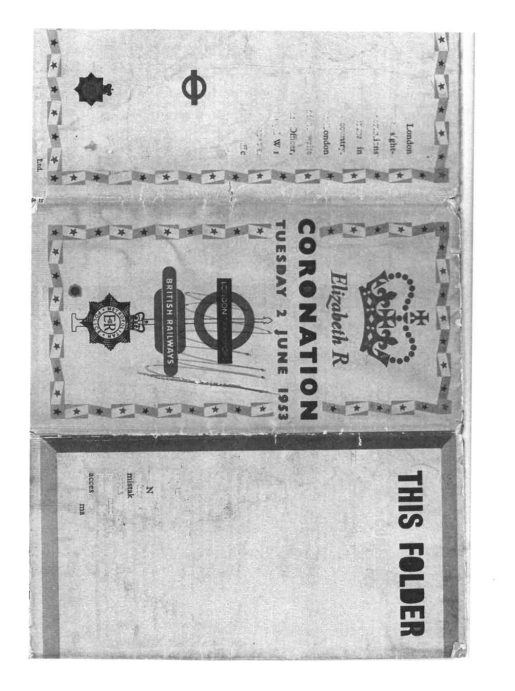

Summer Activities:-

Wymondham Kids’ Camp from 25th July – 2nd September for children aged 5-15. Runs from 9-5p.m. every day – something for everyone. Cost £27 per day and £18 fr half day – For more information visit www.south-norfok.gov.uk/kidscamp

Heritage Museum – Open daily from 1-4p.m. – visit www.wymondhamheritagemuseum. co.uk

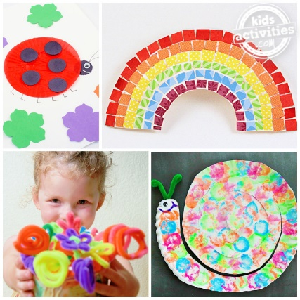
Morley Village and Sports Hall – Huge range of classes, activities and clubs – see www.faceboook.com/MorleyVillageHall

Bubble Football Taster for Kids – Try Bubble Football at Ketts Park for free on 13th and 27th August from 2-3p.m. – Book at leisureoffers.co.uk/south-norfolk-leisure/festival-of-fitness-2022/taster-sessions/

Festival of Fitness runs for six weeks from the 25th July. Water Polo tasters for adults, Fun and Float tasters – more details at www.leisureoffers.co.uk/south-norfolk-leisure

Lifeguard Courses running during the summer – if you are interested email mark.edwards@southnorfolkandbroadlands.gov.uk

WHO LIKES A GOOD PUZZLE??

Rita Harris has lots of puzzles to pass on. If you would like to spend an afternoon doing a puzzle, either speak to Rita or leave a message in the Office and we will see that you get a puzzle.

A WORD FROM ROSEDALES

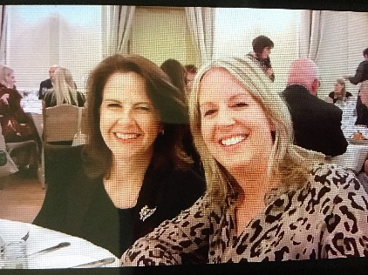

Bereavement and self-care
I am sitting here writing this on the hottest day of the year so far. My garden thermometer says it is 45 degrees out there! Even sitting indoors with all the curtains shut, It is difficult to feel comfortable. I am looking after myself by doing as little activity as possible, drinking plenty of cold water, eating ice lollies and spritzing myself with water from time to time.
On a day as hot as today, I am doing my best to care for myself. If the weather was minus 10 degrees I would also be looking after myself by wearing warm clothes, having hot food and drinks and staying by the fire.
Sometimes, when we are bereaved, we may stop taking care of ourselves. We might think,
‘What is the point of taking a shower and getting dressed today?’ or
‘What is the point of eating well or taking a walk outside?’ or
‘I feel guilty about meeting my friend for a coffee.’
Life without our loved one can feel meaningless and we may think we have lost our purpose in life. We may also feel a lack of motivation or guilt that our life continues whilst theirs has come to an end.
However when we are bereaved, it is even more important to prioritise our self -care so that we protect our mental and physical health and remain well, not just for ourselves but for our remaining friends and family.
Failing to care for ourselves can lead to a downward spiral of depression which may be hard to climb out of. We all need time off and having a ‘duvet day’ once in a while is ok, but if these days are becoming the norm, then you may find these motivational guidelines helpful:
Aim to get up every day at a reasonable time.
Wash every day.
Get out of the house everyday- even if just for a short walk.
Keep your living space clean and tidy- you may decide to get some help with this.
Talk to someone everyday- friends, family- in person or on the phone, call a helpline, speak to a counsellor or join a support group.
Do something enjoyable which is practical, creative or physical -crafts, photography, singing, swimming, DIY etc
Set some short term and long term goals- Take a trip on the bus to the city or the coast, go to the hairdressers, redecorate a room, begin a garden project, find out about volunteering in your community, go back to work.
Achieving even small things will give you a boost.
And finally, remember:
- Even without your loved one, you still matter.
- You do have a future and it does contain happy times.
- You are still a person of immense worth and you still have much to give.
- Asking for help shows strength not weakness.
- Others will help if you reach out.
- Things will get better, you won’t always feel as you do now.
Our next 8 week bereavement support group starts on September 13th at 10am at Wymondham Baptist Church. The groups are free and all are welcome but please book your place by calling 07901 888 122.

Cryptic Song Titles Quiz Answers
- There is not an ounce of truth in this (4 words) – Its only make believe
- Low-cost thoroughfare (2 words) – Penny Lane
- Policeman’s young lady (2 words) – Bobby’s girl
- Celestial small change (3 words) – Pennies from heaven
- Statement of perfect health (3 words) – I feel fine
- Exhibition in North Yorkshire (2 words) – Scarborough Fair
- Golden state babes (2 words) – California girls
- An unspecified location (1 word) - Somewhere
- Pre-owned flower (3 words) – Secondhand Rose
- Lancashire girl who takes the cake (2 words) – Jennifer Eccles
- An enquiry as to breakfast preferences (9 words) – How do you like your eggs in the morning?
- Beaufort scale 10 (2 words) – Stormy weather
- Granite tea room (3 words) – Hard Rock Cafe
- Unearned income (3 words) – Money for nothing
- Rio beach or New York nightclub (1 word) - Copacabana
- Sixty percent of a royal flush (6 words) – From a Jack to a King
- Hours of darkness during June – August (2 words) – Summer time
- Bring on precipitation in triplicate (6 words) – Let it snow, let it snow
- Song by Martin Luther King JR (4 words) – I have a dream
- 100% or zero (3 words) – All or nothing

Answers to last issue’s quiz

A picture to colour …………….
++

A CHALLENGE FOR THE SUMMER:-
Set yourself a target, how many of the following can you do during the summer:-
(Let us have a photo of you doing one of these things for our next issue)
- Climb a tree and listen to the wind blow through its leaves
- Build a sandcastle
- Take a walk in the forest and observe nature around you, collect 3 things
- Find 5 different pebbles on the beach
- Have a picnic in the woods or on the beach
- Find some slimy seaweed
- Collect as many sensory things as you can – e.g. prickly holly, smooth stone
- Walk on the sand and paddle in the sea
- Build a Bug House
- Read 2 books
- Spot some birds and listen to their song
- Eat something new
- Watch the bees on the flowers – can you hear them buzzing?
- Do a jigsaw puzzle
AUGUST/SEPTEMBER - DATES TO REMEMBER

August 1st – 13th – Big Church Clear out and Clean
August 3rd – Rosedales monthly meeting – a.m.
August 5th – Roots Community Café – 10.00a.m. – 1.00p.m.
August 7th – Worship at 10.30a.m. taken by Vic and Ray’s Home Group
August 7th – Invite to Attleborough Baptist Church to meet Alan and Megan Barker
August 8th – Roots Community Café – 10.00a.m. – 1.00p.m.
August 8th – Informal Leadership Team Get Together at 65 New Road Hethersett
August 12th – Roots Community Café – 0.00a.m. – 1.00p.m.
August 13th – Big Church Clean
August 14th – Worship at 10.30a.m. taken by Christine’s Home Group
August 15th – Roots Community Café – 10.00a.m. – 1.00p.m.
August 21st – Worship at 10.30a.m. taken by Neil Starling
August 28th – Worship at 10.30a.m. taken by Ramona Chenery
Sept. 2nd – Roots Community Café – 10.00a.m. – 1.00p.m.
Sept. 4th – Worship at 10.00a.m. – 1.00p.m. BBQ after morning worship
Sept. 5th – Roots Community Café – 10.00a.m. – 1.00p.m.
Sept. 5th – Finance Team Meeting
Sept. 7th – Rosedales Monthly Meeting – a.m.
Sept. 9th – Roots Community Café – 10.00a.m. – 1.00p.m.
Sept. 9th – Friday Night Youth
Sept. 11th – Worship at 10.30a.m.
Sept. 11th – Prayer Gathering in the Market Cross
Sept. 12th – Roots Community Café – 10.00a.m. – 1.00p.m.
Sept. 12th – Leadership Team Meeting – 7.30p.m.
Sept. 13th – Rosedales Bereavement Course – a.m.
Sept. 13th -Thrive@Roots – 2.30p.m.
Sept. 14th – ECO Team meeting at 3 Jackdaw Close – 7p.m.
Sept. 16th – Roots Community Café – 10.00a.m. – 1.00p.m.
Sept. 17th – TWAM Collection
Sept. 18th – Worship at 10.30a.m. – TWAM Focus
Sept. 19th- 25th - EBA Week of Prayer
Sept. 20th – Rosedales Bereavement Course
Sept. 20th – Thrive@Roots – 2.30p.m.
Sept. 23rd – Roots Community Café – 10.00a.m. – 1.00p.m.
Sept. 23rd – Friday Night Youth
Sept 24th – EBA Gathering
Sept. 25th – Café Church at 10.30a.m.
Sept. 26th – Roots Community Café – 10.00a.m. – 1.00p.m.
Sept. 27th – Rosedales Bereavement Course – a.m.
Sept. 28th – Windmill House Service
Sept. 30th – Roots Community Café – 1.00a.m. – 1.00p.m.

Further information about Wymondham Baptist Church or to contribute to our magazine please contact the office – office@wymondhambaptist.org or ring 01953606520 or check out website – www.wymondhambaptist.org

Freezer Savvy
How to save food waste and energy by getting the most out of your freezer

1/3 of all food produced globally is wasted. In the UK, up to £730 of food is wasted per household per year. You can use your freezer to cut down on food waste, save money and save energy, so reducing your greenhouse gas emissions.

Energy saving freezer tips

- Fill the freezer. This makes it work more efficiently and is more economical to run. Top up with bread, milk, peas or cold water packs for summer picnics
- Seal the deal. Close the door on a piece of paper. If the paper stays put, the door is well-sealed. If not, the seal needs replacing.
- Peek, pick, close. Don’t leave the door open when taking food out. The more cold air that escapes, the more energy needed to cool it down again.
- Hold it on the hot. Let hot food cool completely before putting it in the freezer.
- From frozen to fridge. If thawing food from the freezer, put it in the fridge. This keeps the fridge cool without using energy
- Love at frost sight. The more ice your freezer has in it, the more energy it uses. If the ice is more than 1cm thick, it needs defrosting.
- Store it right. Label everything with name and date. This will mean less time with the door open and more energy saved.
- Check the temperature. Freezers should be set at -18 degrees C. Too cold wastes energy and too warm leads to premature food spoilage

By Nicola Maunders, Greening Wymondham
www.greeningwymondham.org

LOVE EVERY DROP?
It takes a while for hot water to reach my kitchen sink even though the hot water cylinder isn’t very far away. Instead of just running the tap allowing the runoff water to go down the sink I collect it in an empty, clean, four-pint plastic milk bottle. I keep this bottle under the sink and use the water to fill the kettle when I want a hot drink, water the plants on the window cill or elsewhere or just rinse the sink round when it’s messy.

I took the time to measure the amount saved this morning and it was 1.3 litres, (2 and a half pints). This would mount up to quite a lot in the course of a week even if you use a dishwasher for most items as I do.

In a time when saving everything possible is so important I thought I would share my ‘daftness’ as my husband calls it. Since I dislike throwing anything away before it has been used at least twice, if anyone would like a clean plastic 4 pint milk bottle to try this out please let me know and I will happily bring it to Church for you, so you, too, can ‘love every drop’.

Please do not drink the water if your hot water cylinder is fed from a tank in the loft as it cannot be guaranteed fit for consumption.

Penny Seall

Beware
According to local news, Asiatic hornets have been seen in East Anglia. They came with the information that they can severely damage our insect population but no health warning was given. My husband, John, was stung by one while we were in France. He reacted immediately and had to go straight to the doctor - not a possibility here - and was prescribed suitable medicine. His arm had swollen up dramatically and the effect lasted for several days. These hornets are very aggressive and attack extremely quickly, so a professional with protective equipment is needed to deal with them.

Penny Seall

Caution…..

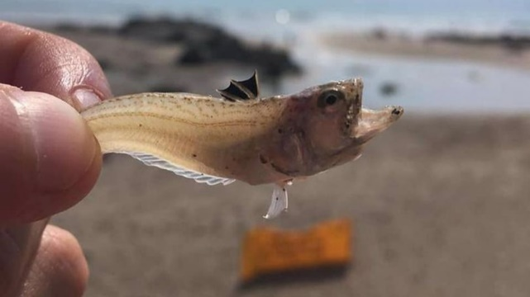
Weever fish are found all round the coast. They like to bury themselves in soft sand so are often in the sea on our most popular beaches. Now for a fish that’s only 2 inches long you wouldn’t think it was a threat. However, many many adults and children every year step on them.

Unfortunately they have a poisonous spine on their backs…and the pain??? Well lets say it can be holiday spoiling.

So how to protect yourselves….the easiest way is to purchase some beach shoes, they can be purchased pretty much everywhere and are cheap…better eco friendly if you take them home and bring them next year!!

If you decide to risk going bare foot and fall foul. There are no quick treatments but a simple one does exist – hot water, as hot as you can stand it and change regularly for 60-90 minutes
Also tweezers to remove any spines. (They keep pumping toxins if you leave them)

However I warn you … the pain is intense. Like nothing you have ever felt – my suggestion buy the beach shoes.

DON’T WASTE FOOD – SOME IDEAS

On Sunday July 24th Paul spoke about the amount of some common foods which are wasted daily in the UK. The scale of the waste shocked many of us. So I am going to share a few ideas which I use to prevent wasting food.
Apples - Eating apples can be cooked, even if they do not go as soft as cooking apples. Use them in cakes, pies or to make apple sauce, or make them into juice.
Bananas - Peel them and freeze them to make smoothies (tip from the Smith family). Make banana bread.
Carrots - If going a bit soft cut off the ends and soak in cold water for a few hours.
Potatoes - Peeled uncooked potatoes in cold water will keep in the fridge for several weeks.
Bread - Make breadcrumbs, bread pudding, top fruit instead of using a crumble mix.
Milk -Milk keeps past its use by date. Use leftover milk in cooking, custard, semolina, or cheese sauce.
What tips do you have for saving food from going to waste. Let’s start a conversation and help the planet!
Christine Spencer

A GOOD BOOK

Recently I read the extraordinary true story of the life of Kathy Diosy; a Jewish lady and her growing up years during world War 2. The book is entitled “Forgiving Hitler”.
Kitty as she liked to be known, was born in Budapest. Both her parents were Jewish, although non-practising. She explains about growing up in Hungary and about losing every male member of her family in death camps and some of the horrors she, herself, had experienced.
Her daughter, Juliette, started going to church through a school friend who attended. This led to Kitty being introduced to the minister. As well as going to church Kitty started going to Bible Study. As she learnt about Jesus and His love, the bitterness within her started to melt.
The following year, 1974, Kitty’s birthday, June 16th, fell on a Sunday. That particular Sunday the minister preached on knowing Jesus; not just knowing about Him. This he said, required a response. That day Kitty responded, she asked Jesus to forgive her and change her and take over the running of her life both now and forever.
Later, Kitty said the shadow of anger and bitterness has finally gone, Since making that commitment to Jesus, the shadow of Hitler and all the evil and pain and suffering he caused has been driven away.
Kathleen Garlish

ENERGY SAVING TIPS…
Reducing your energy consumption doesn’t have to start with big changes, small changes can make a huge difference:-
- Turn off appliances that are on standby mode – this small change could reduce your electricity consumption by an average of 2.5%.
- Check for draughts – draft proofing could reduce your consumption by as much as 15%.
- Switch to energy efficient LED bulbs – The amazing thing about making this switch is that you reduce the amount of energy you use for lighting by nearly 90%.
- Only boil water you need – If we all only boiled the water we needed for a cup of tea, we’d save enough electricity a year to power the UK’s street lights for a month.
Bike, Walk, Drive …….in the Norfolk countryside – Saturday, 10th September 2022

A fun day out for all, stopping off at as many Churches and Chapels as you can!

Pump up your tyres, dust off your walking boots, pack a picnic and plan a route from your own door to visit as many of the most beautiful churches in Norfolk as you can.

See more information on the notice board.

BIG CHURCH CLEAN/CLEAR OUT

During the first two weeks of August we will be undertaking a big clear out throughout the church building – we have already started!!! Each area will be cleared of all items that are no longer used. A skip will be in the church car park from 2nd August to 18th August for the disposal of anything that is not needed and cannot be re-used or recycled in any way. All leaders are asked to clear the areas that have been assigned to them. On Saturday August 13th we need your help to carry out an intense clean of the premises. A schedule is displayed in the church hall for you to indicate what time you can give to help in the Big Clean. Sharing the work will mean that no one will be over-worked. Please make sure that you sign up. Thank you.

Thank you.

CHILDREN EAT FOR LESS – For the Summer holidays
Morrisons – Free child’s meal for every adult meal purchased @ £4.99 or over
IKEA – 2 kids hot meals, jelly, fruit and drink for £5
Dunelm - One Free-Mini Main, 2 snacks & drink for every £4 spent in in-store Cafes
Dobbies – Children eat free with an adult main meal
Asda – Children eat for £1
Whitbread – 2 kids under 16 eat free with every adult breakfast
Beefeater and Brewers Fayre – 2 children under 16 can get a free breakfast everyday with 1 adult meal
Tesco – Free kid’s meal to any Clubcard holder with any item purchased in a Tesco café
Marks and Spencer – Kids eat free deal when £5 or more is spent by an adult

Home
from
Home
Would you like to be part of something new that we are hoping to set up between the end of September and March of next year, on Wednesday and Thursday afternoon, between 2.00p.m. and 5.00p.m. All of us will be facing the effects of increased energy costs and for some it will mean the choice of heating or not heating their homes or living in very low temperatures. Home from Home is designed to provide a warm space in the church for everybody where they can simply come, meet with other people, play board games, do puzzles, read the newspaper, chat and enjoy tea/coffee and biscuits. We are looking for a group of people that will be happy to be part of the hosting team for this project. If you are interested in learning more, please speak to Ray or Cathy Finch.

SAVE THE DATE AND SAVE YOUR TOOLS!!

On Saturday 17th September Wymondham Baptist Church is holding a collection day for Tools with a Mission (TWAM) from 10am to 4pm.

What is TWAM? Tools with a Mission is a Christian charity that collects unwanted usable tools, refurbishes them, sorts them into trade tool kits and sends them to the developing world for livelihood creation. TWAM sends around 16 containers filled with a total of around 225 tonnes of tools every year. These tools range from sewing machines and knitting machines to carpentry tools and mechanics’ tools. Apart from keeping the old tools out of landfill, the newly refurbished tools give the recipients the means to generate their own income, create their own businesses and build a mindset of independence, not reliance.

Elias completed a welding course and is now working and planning to open his own workshop to train others. What can you do to help us? Please start collecting usable, not broken tools to bring to Wymondham Baptist Church on Saturday, the 17th September.

We will accept garden tools, sewing and knitting machines, carpenters’, plumbers’, motor mechanics’ tools as well as power tools, electricians’ and builders’ tools. We also accept
fully working IT equipment: desktop computers and laptops running a minimum of Microsoft Windows 7, tablets, switch routers and cables.

What impact do these tools have: Harriet’s story

Harriet had a poor upbringing with no educational opportunities. With no qualifications, she was unable to get a job and was bringing up her two boys on her own. She was then given the
chance to take up a tailoring course and on completion, was given her own sewing machine, provided by TWAM. She now has her own shop, making and altering clothes and because of this, she is able to provide her children with a much brighter future. For more details about the charity and a full list of what can be accepted, please look on the TWAM website:
www.twam.uk

Thank you in advance for your help and we look forward to seeing you and your unwanted tools on the 17th September.

SOME PHOTOS FROM OUR GALLERY

